1
Last Friday , Emma and her colleague David discussed their plans for the weekend .
Emma wanted to go to the mountains , because she goes climbing every Saturday .
David had never climbed , but he decided to accompany his colleague Emma .
The next morning , Emma and David found each other at the foot of the mountain .
At first , Emma thought that David could not climb easily ,
because he did not look very strong . But after a few minutes ,
he managed to move faster than she did .
Emma and David finally arrived on top of the mountain .
That's where they had lunch .
The next time , they will go to another area and climb a higher mountain .
正解を選んでください。
１) エマとデービットは兄弟である。 ２) エマは、３０歳である。
３) ２人は山のふもとで待ち合わせた。 ４) エマとデービットは山の頂上でランチを食べた。
５) ２人はワインも持って行った。 ６) エマとデービットは次回もっと高い山に登ることにした。

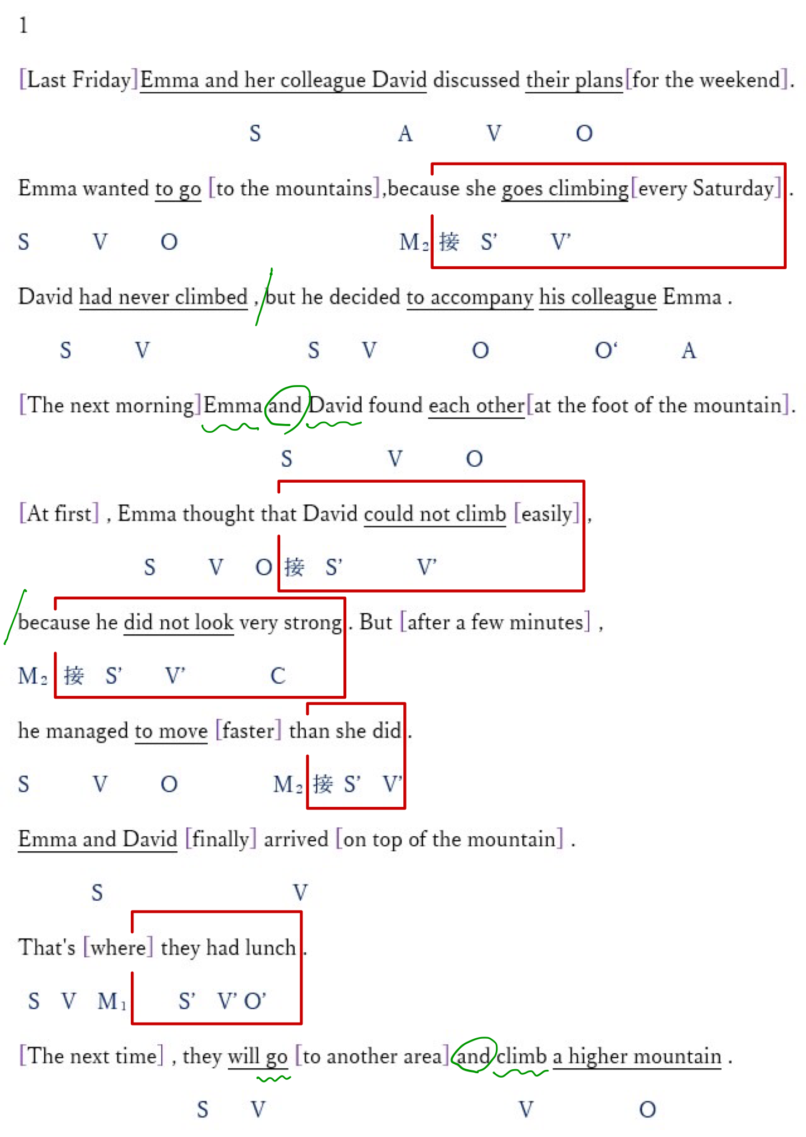

2 Yoshiko is a chocolatier in Geneva . She has lived in this city for 15 years .
When she was a student at the university , she made her first trip to Geneva .
First , she was interested in the painting ,
but finally, it was the Geneva chocolate that she loved the most . At that time,
she decided to become a chocolatier. After finishing her studies in Japan ,
she returned to Geneva to go to the national pastry school .
And then , she worked in a shop as a pastry chef for nine years .
Finally , she opened her shop in Geneva .
In the early years , few people came to buy her chocolates .
But now she receives two hundred customers a day .
正解を選んでください。
１) 彼女は画家である。
２) よし子ちゃんは、４０歳である。
３) よし子ちゃんは日本の大学を卒業した。
４) 最初は仕事がうまくいっていなかった。
５) よし子ちゃんは今 多くのお客さんを持っている。

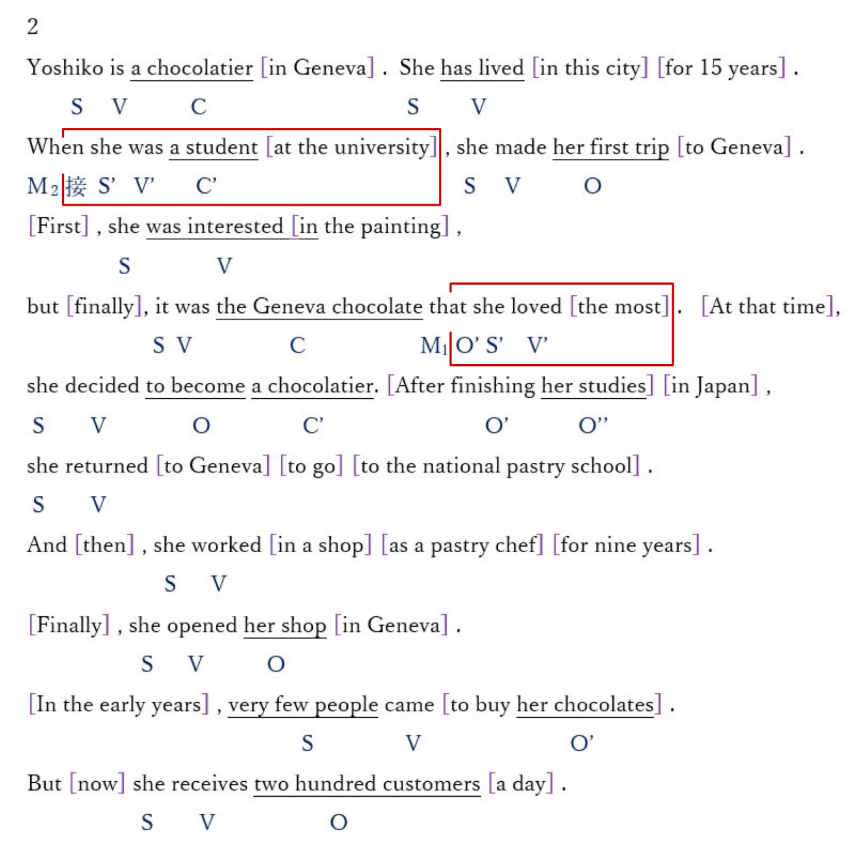

3 Ken's grandmother is 95 years old .
She is a very active lady who always wants to do new things .
Last year , she started to study Itaian .
Her teacher is the boss of an Italian restaurant .
The Italian language pleases her a lot .
She would like to go to Italy . But Ken's parents are worried .
They asked Ken if he did not want to go to Italy with her grandmother .
Ken loves his grandmother and he likes to travel .
He is delighted to be able to make this trip .
But he does not speak Italian at all . So he will study it tomorrow .

正解を選んでください。
１) 彼は日本人である。 ２) 彼の祖母は、９０歳である。
３) ケンは旅行が好きである。 ４) ケンはイタリア語を少し話す。
５) ケンは祖父が好きである。 ６) ケンは明日からイタリア語を勉強する。

4 Since his childhood , Noah went to the city library every Saturday .
In this library , he met young people of his age and he often made friends .
Last year , there was a fire in the library which was built of wood .
Fortunately , no one died , but the fire destroyed the building .
After this accident , the city decided to build a new library .
Noah and his friends wanted to do something to help .
They asked people to donate books for the library .
Finally, many books were donated to the city that Noah lived in .
Noah is very happy . The new library will open next year .
正解を選んでください。
１) ノアは図書館に行ったことがない。 ２) 新しい図書館は来年オープンする。
３) ノアは図書館で友達を作った。 ４) ノアの都市は図書館を再建する。
５) ノアは毎週土曜日プールに行っていた。 ６) 多くの本が図書館に寄付された。

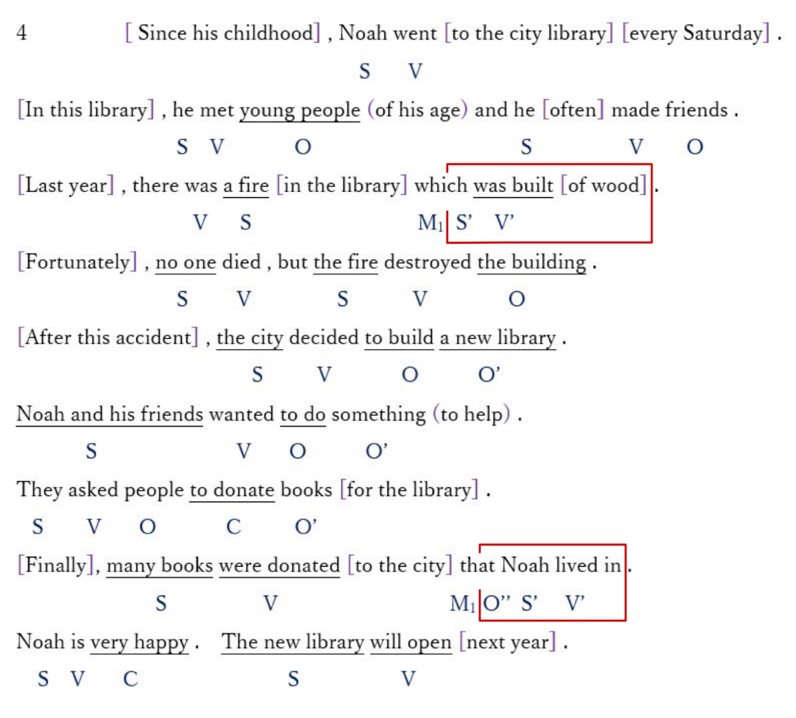

He looked at her. 彼は彼女を見た。 自動詞
He saw her. 彼は彼女を見た。 他動詞

5 Each year , the Morton family spends their summer holidays abroad .
Last year, they went to the United States .
But this year , it is difficult for them to go abroad .
Because Ms. Morton lost her job last month
and that her husband has less and less work in his factory .
Finally , they decided to travel only a week in German .
The children are not happy .
If this situation continues , the Morton will not be able to go on vacation next year .

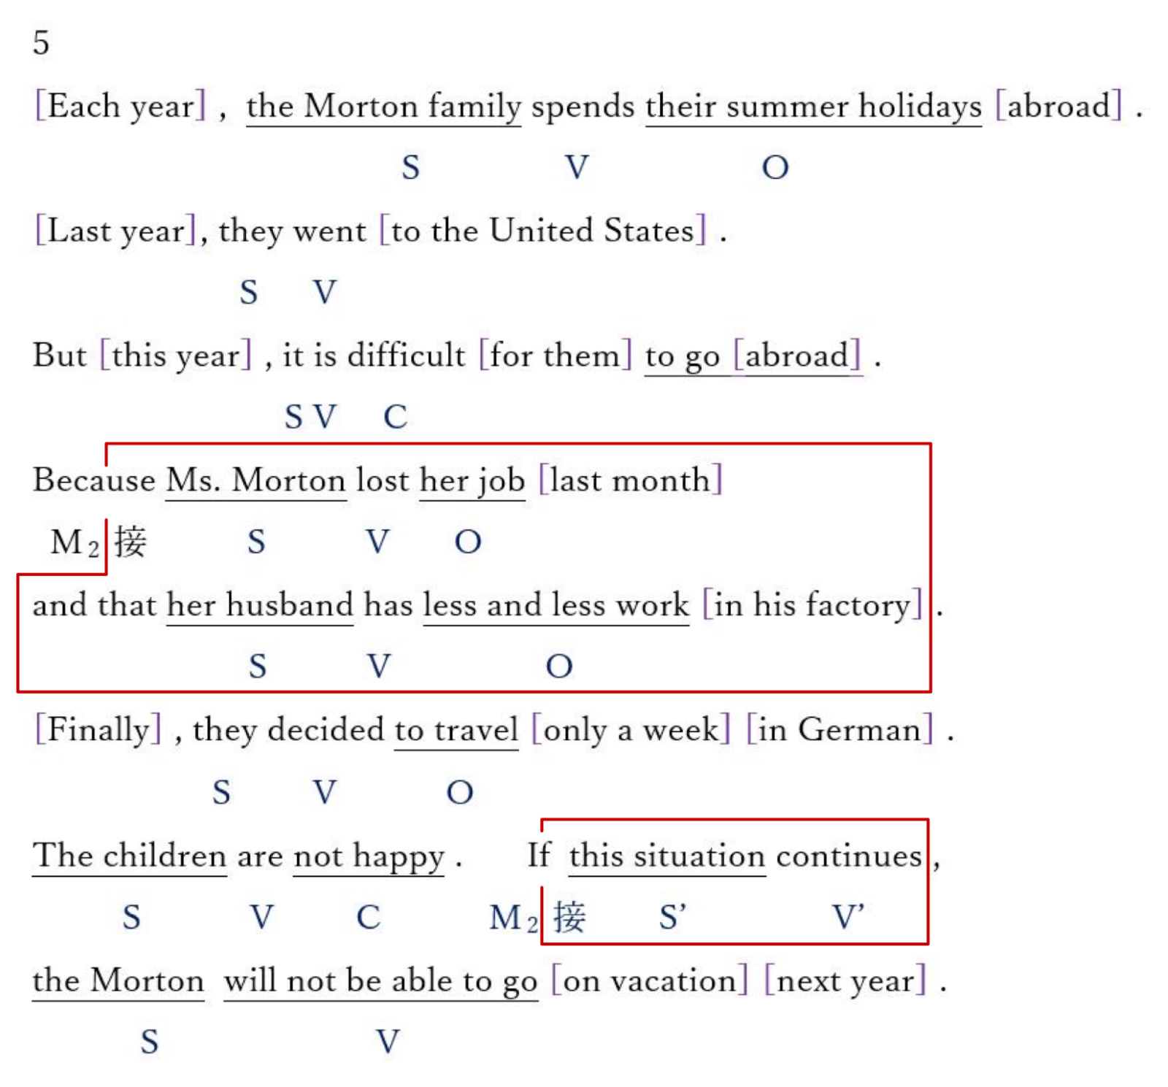

6
Since September , Ken's father has been teaching English at a university in Tokyo.
He rented a house near the university and he lives there with his whole family .
Ken is 19 years old . He goes to a Japanese college .
He works well and he started playing baseball in the college club after school .
He has a lot of friends in this club .
Thanks to them , he speaks better and better Japanese .
The only problem is that at night, at home , he is too tired to finish his homework .
Sometimes he falls asleep right after dinner .
So he decided to get up at 5 o'clock in the morning to do homework .
It works well .
As he can concentrate better than the evening , he finishes his homework faster .

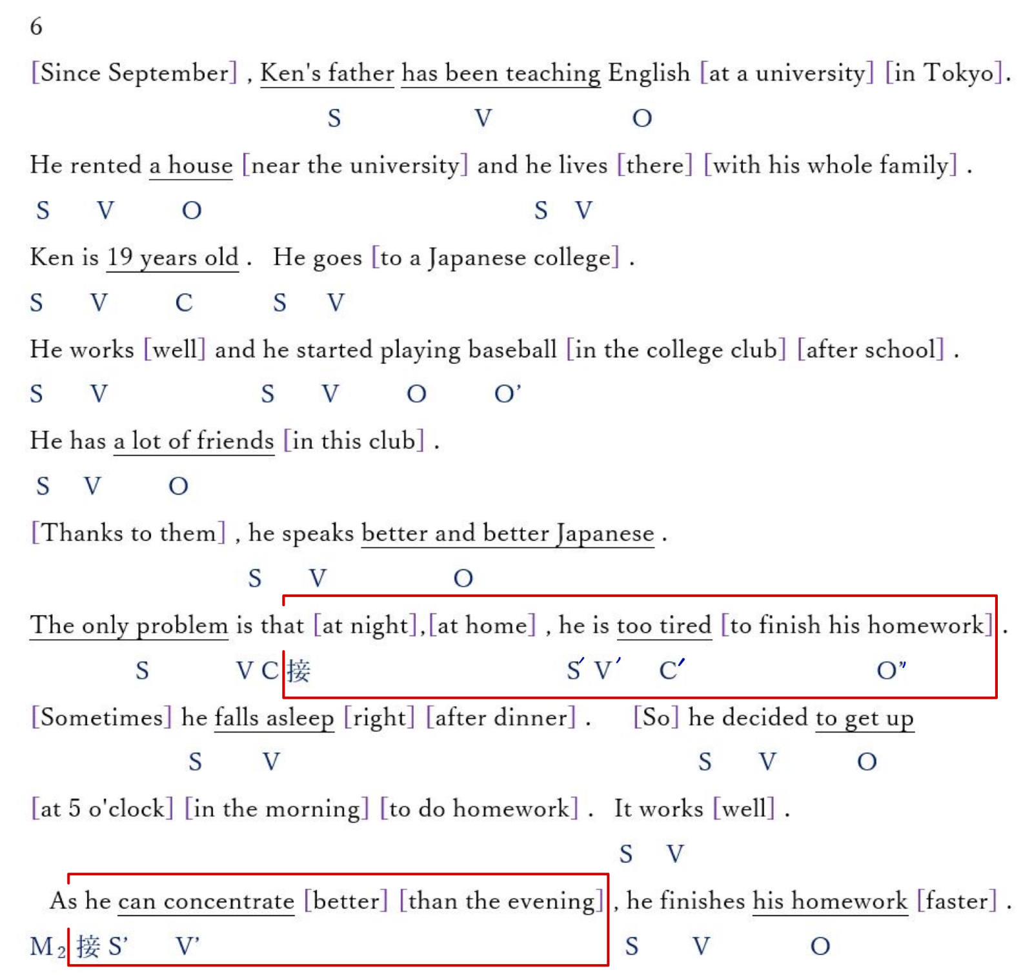

7 Paul lives in a small town .
He is always very busy and sometimes works even on weekends .
When he is not working , he listens to music at home .
He likes classical music a lot .
If there was a concert hall in his city , he would go several times a year .
For a long time , he dreams of going to the concert in Tokyo .
At the beginning of March , he asked for a week of vacation . But
he could only take three days at the end of the following month . Before leaving ,
he found the concert of a great orchestra which took place during his stay in Tokyo .
Unfortunately , we could no longer reserve places on the Internet .
The day of his arrival in Tokyo ,
he went to the ticket office in the concert hall and managed to buy a ticket .

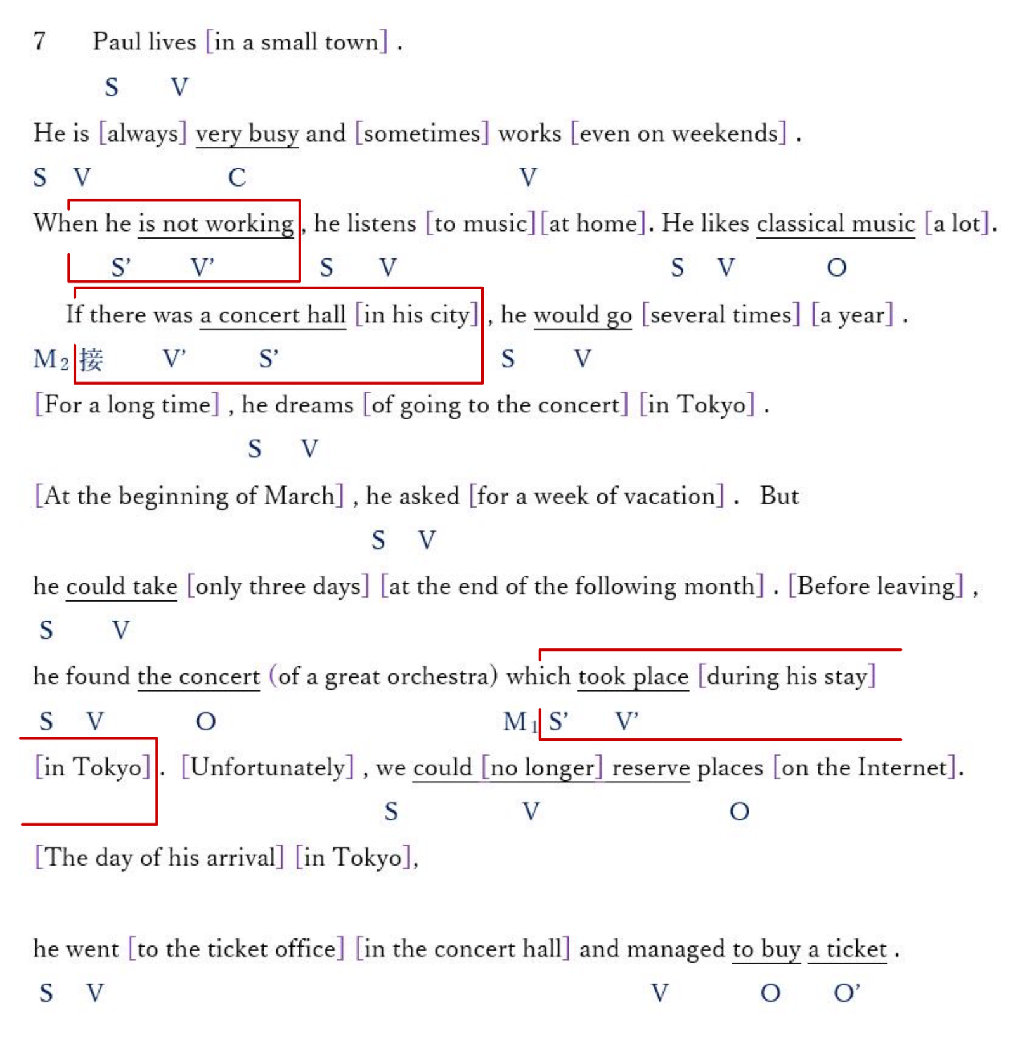

8 I live in a small village since my childhood .
There are beautiful mountains around this village . Several rivers flow .
I walk in the forest every morning before going to school . I enjoy nature .
Last month ,when I walked by the lake , there were some birds that I did not know .
The next day I went to the library in my town .
According to one book , these birds normally live further south .
So they had gone up here , to the north ! Last week, in the forest ,
I discovered three species of butterflies that I had never seen here.
These butterflies come from the south too. Now, I am also looking for new plants .
And I started to take the temperature in this forest . One says
that the movement of animals and plants has a certain relation with temperature .

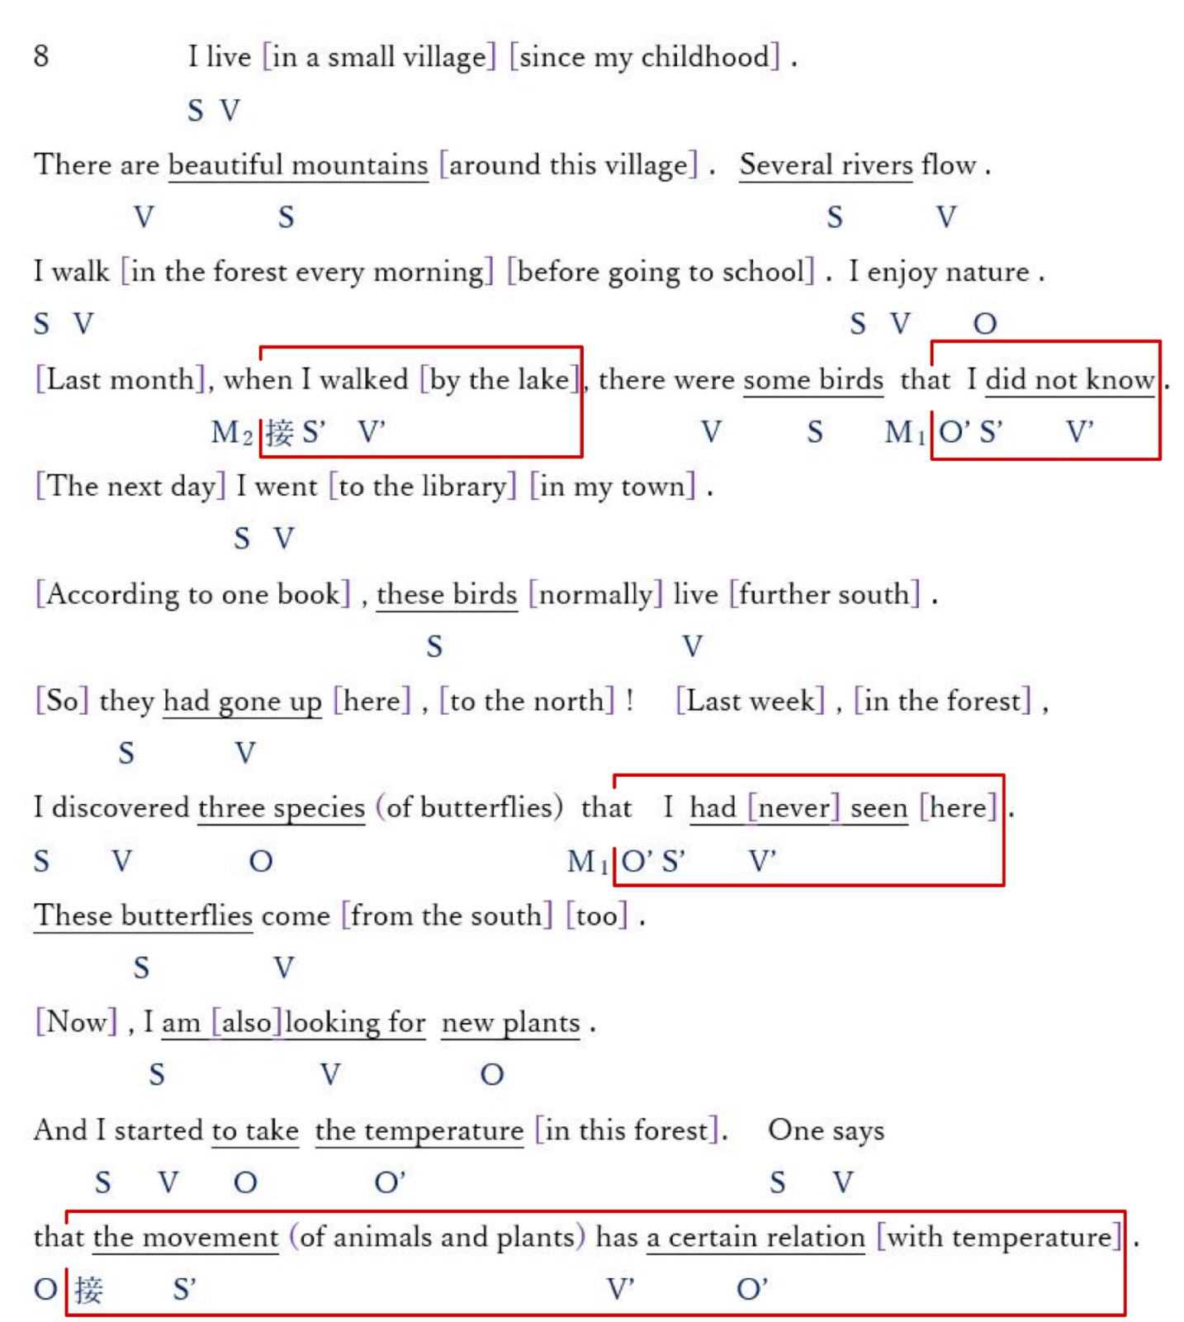

9 Ethan, his wife and their son used to love watching TV .
They spent more than five hours a day in front of the television
and stayed late at night . But today , they do not look at it anymore .
Last month, they moved . In their new apartment , television did not work .
In the evening , to pass the time ,
Ethan and his family read books and they enjoyed this quiet evening .
Ethan thought
that television was not so important and he decided not to look at it anymore .
The next day, he talked about his idea to his wife and son . Both agreed with him .
Now they read more books than before and they go to bed early .

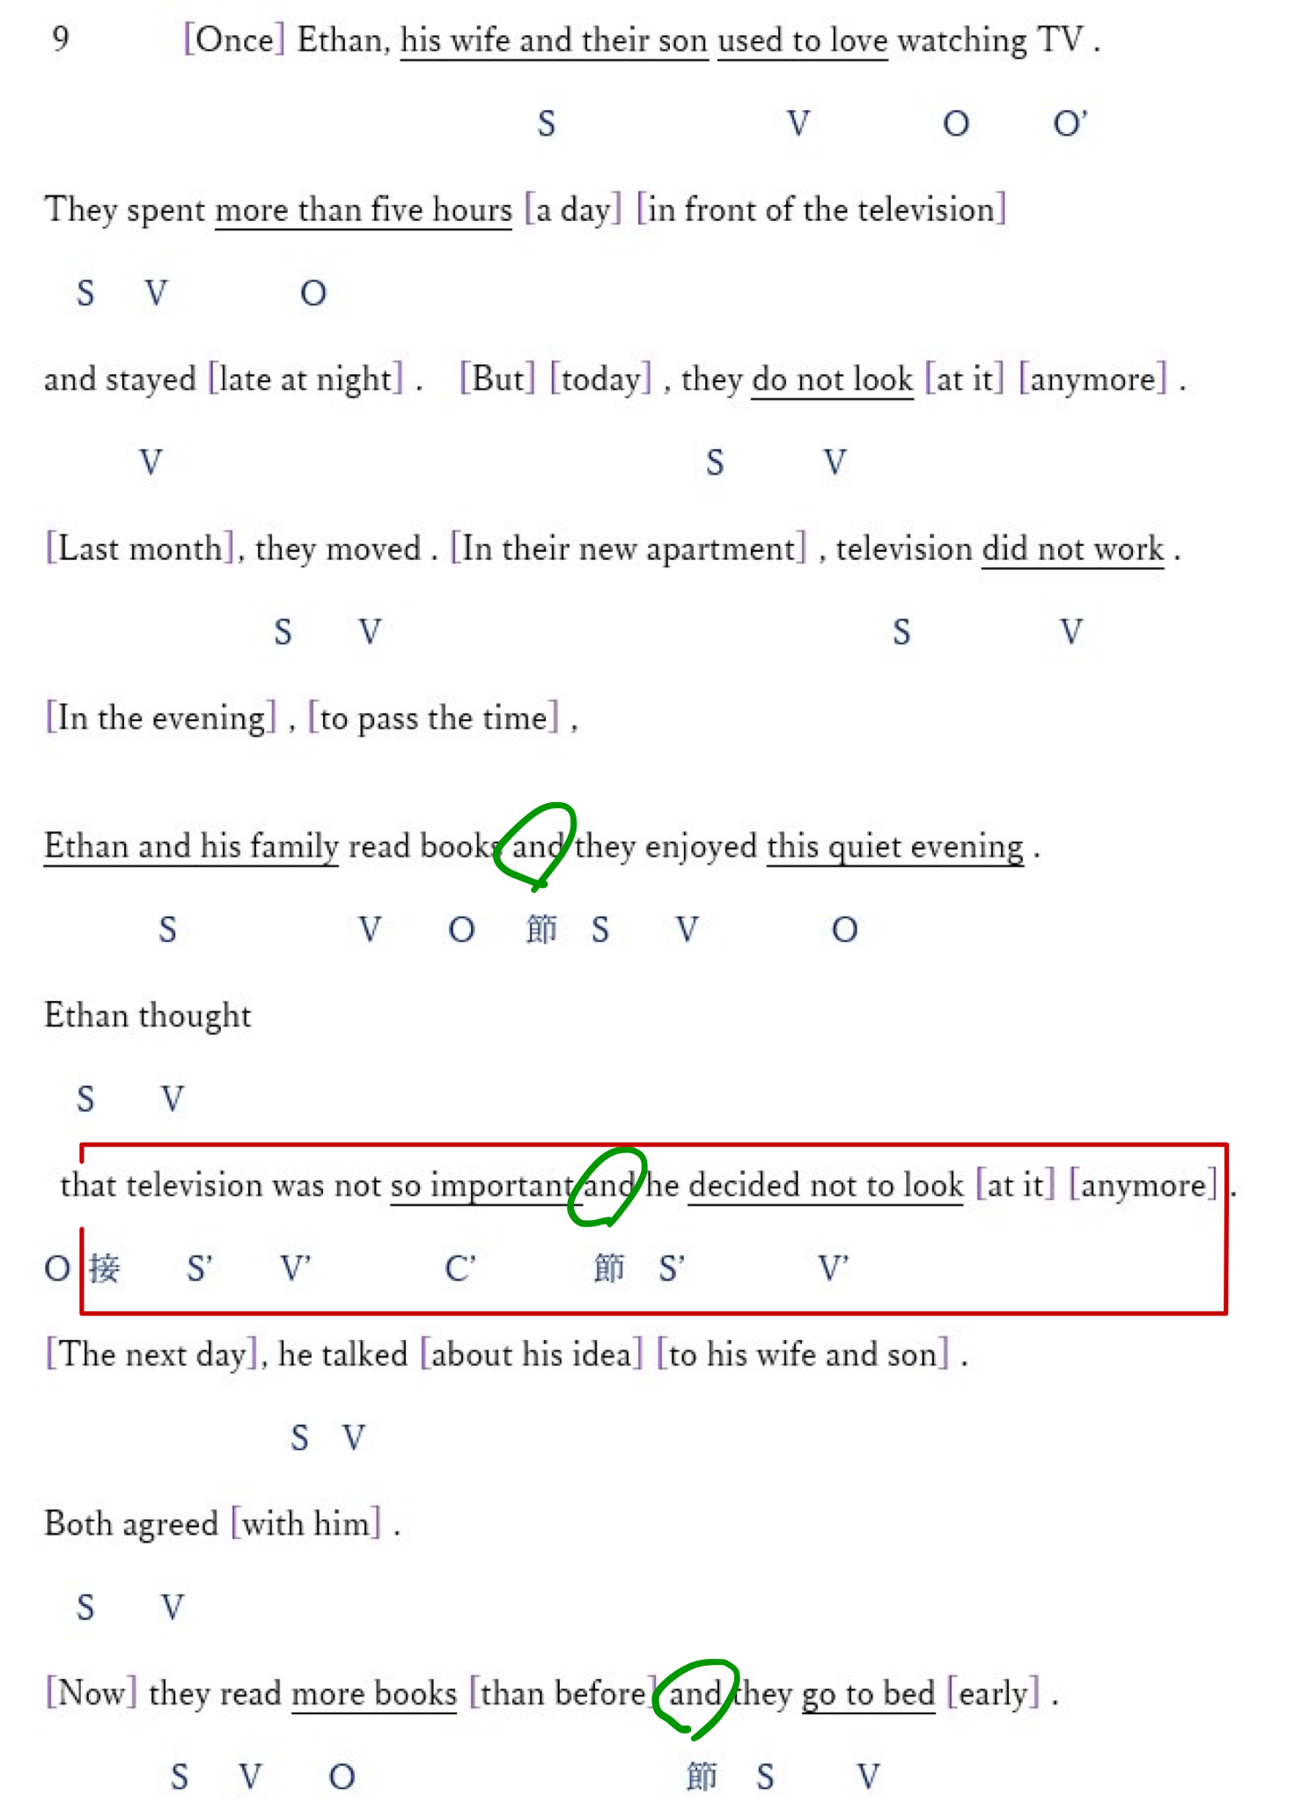

10
I am a clown . I go to the hospital every Tuesday to make sick children laugh.
In Switzerland , there are more than 75 clowns like me .
We regularly visit several hospitals .
We give children the opportunity to laugh, sing and dance.
Having fun with us, they may be able to forget their illness for a few moments.
I spend in the rooms with one of my colleagues .
Depending on the room , we change our program.
Anything is possible : a simple hello , a funny song , or a small play .
Doctors are happy with our work .
They think we are allowing children to better fight the disease .
We work with them .

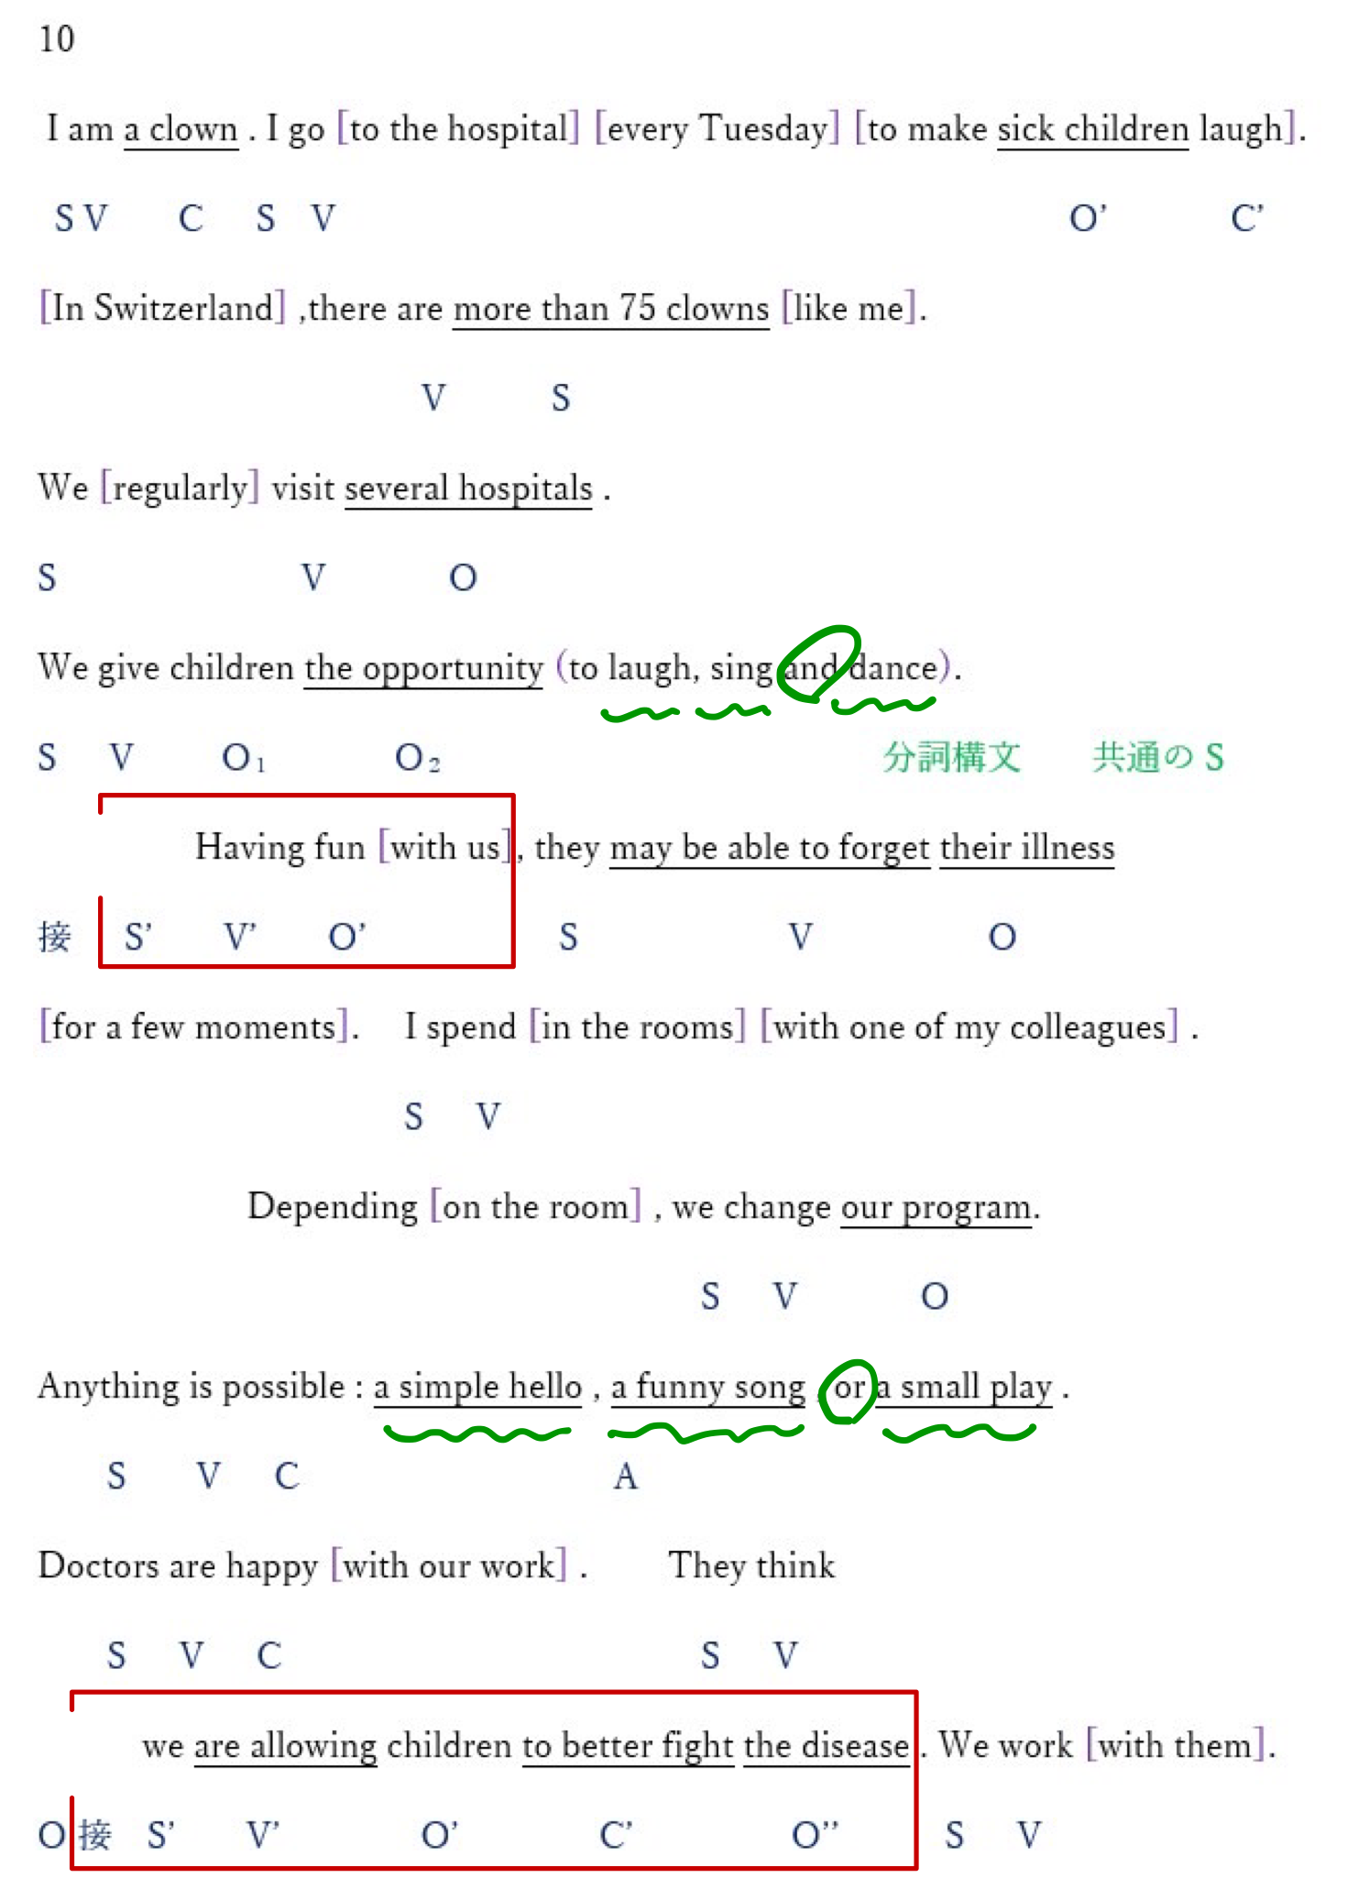

11
I like painting . Sometimes, I go to the countryside to paint landscapes .
My wife , who adores my paintings , always tells me :
"You have to make an exhibition! " For six months , I searched for a place
to exhibit my works . There are of course some galleries in the city
where we live , but it is too expensive to rent one . One day ,
a friend told me about a cafe where you could exhibit for free .
In this café , many customers are interested in art .
They can look at pictures or photos while having a drink ,
and buy the works that they like . I will soon have my first exhibition in this cafe .
I'm happy to meet people who love painting .

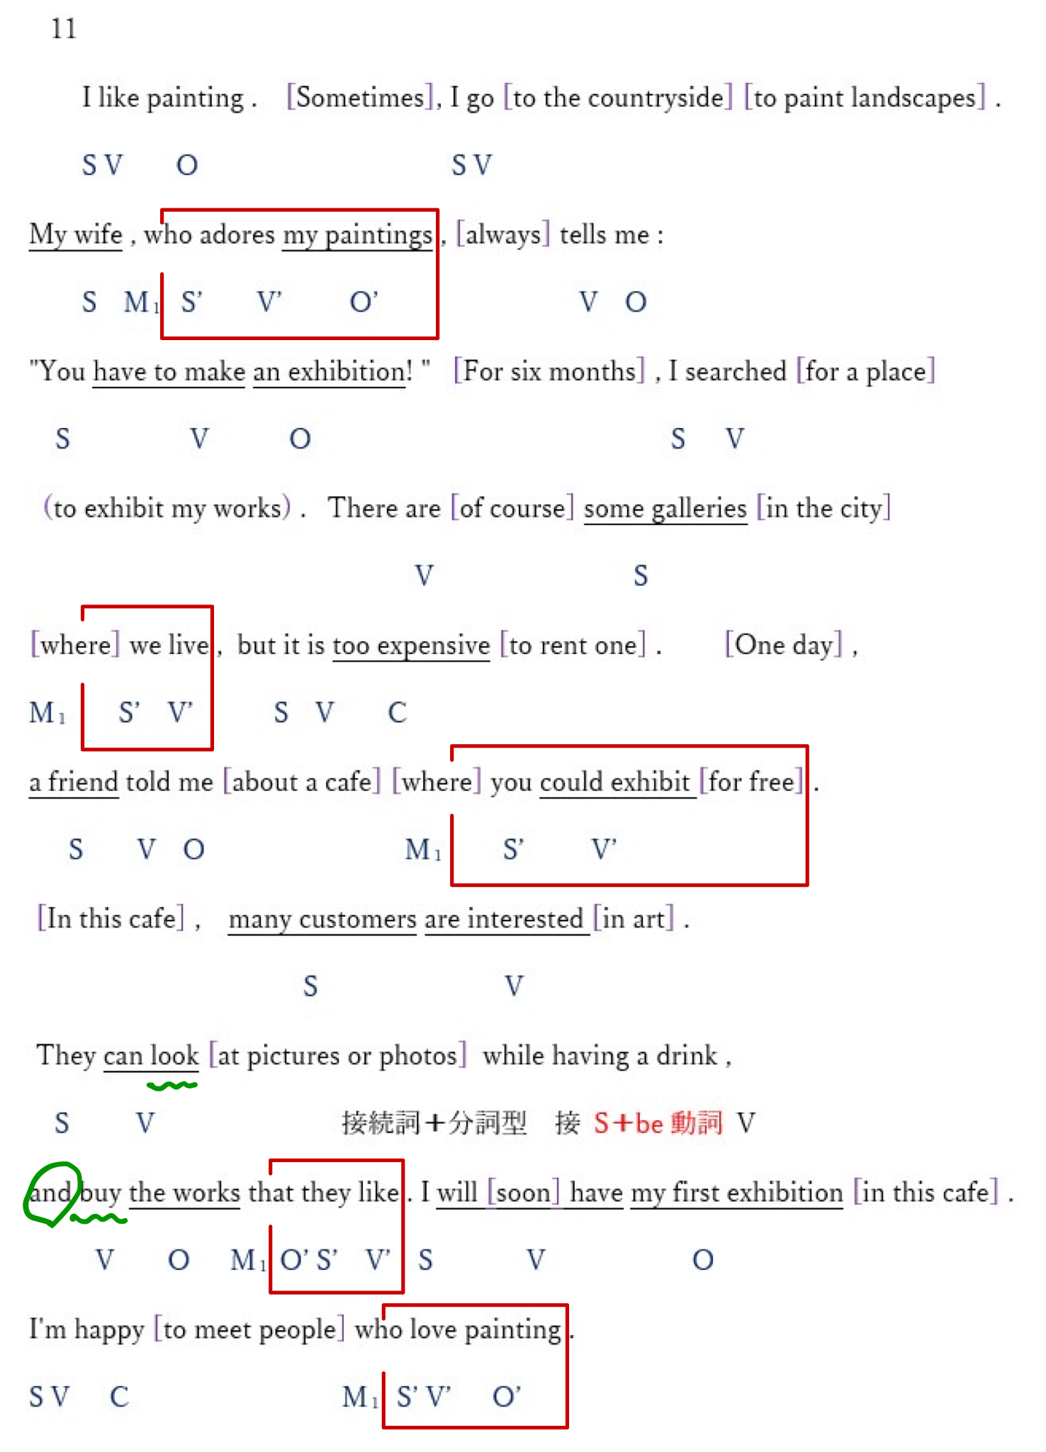

12 This year we have a new English teacher . His name is Poul .
He is American , just arrived in Japan . Before coming to our high school ,
he taught at a school for foreigners in the United States . He's very nice .
When we arrive at the classroom , he is already waiting for us at the entrance .
He says hello to each student and shakes his hand . At the end of the class ,
He goes to the door of the room again to greet us .
He looks at us attentively and tells everyone different things .
For example , he told me last time , "You did a good job," and to Kaede
"You repeated well after me ." At first we were surprised and shy .
Now we answer him with a smile in English of course.

